Case Example: Pat
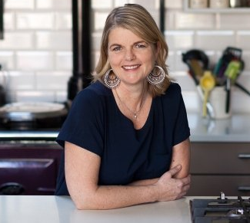 | - 45-year-old  - Married  - 3 children (11, 15 and 18 years old)  - Employment - admin at local elementary school  - Diagnosed with pre-diabetes 6 months ago and hypertension 3 years ago  - Smokes 3-4 cigarettes per day  - BMI 33 kg/m, A1C 6.3%  - Pat spoke with physician saying she was thinking about becoming healthier.  - Family physician referred her to speak with you

- What could be making it challenging for Pat to manage her health?

- When thinking about your first visit with Pat, what Stage of Change is she at for improving her health?

- What affirmation(s) might you provide to Pat?

- Suggest an open-ended question when talking with Pat.

- How would you work with Pat to help her make behaviour change?

